Order of DAF-16-GFP Subcellular Localization Assay
Date： Nov 5, 2021
NO.: 2021110501
- Information from the client
Table 1 Information from the client
Name: |  | Institute/ university:
PI (If different from above): |  | Department：
Tel: |  | E-mail:
Delivery Address:
Billing Address (If different from above):
Is the client willing to share his/her name, lab, and email address with SUNY’s future clients if they inquire? _______
How did the client learn about SunyBiotech? _________
- Email B) Mail C) Website D) From colleagues or friends
E) Other
(If the client chooses D, please write down the referrer name and institute and SUNY will apply 5% OFF to both the client and the client’s referrer. But please kindly note the 5% OFF is only applicable when the referrer comes from other labs.)
- About this assay
The purpose of this assay is to analyze the subcellular localization of DAF-16::GFP. For every strain, one/three replicate(s) will be conducted. For every/ three replicate(s), at least 30/ 90 worms will be tested.
- Information about the tested strains
  - Please complete the strain information including strain name, genotype, phenotype and culture condition in the below Table 2.
  - If the clients want to treat the worms with specific drugs, please complete the Table 3.
  - Please send all strains/drugs to Sunybiotech. If client’s wild type N2 strain is used as control, please also include the wild type N2 strain when sending strains to SUNY.
  - Is the drug sterilized or not? ( for example: yes, no). If not, please provide the sterilization method . If the syringe driven filtration is required, please choose the pore size of the syringe driven filter (0.22µm or 0.45µm).
  - The drug should be added into for C. elegans culturing. (for example: NGM, OP50).
Table 2 Information about the strains
Strain name | Genotype | Phenotype | Culture condition
TJ356 | daf-16p::daf-16a/b::GFP + rol-6(su1006) | Rol
Table 3 Information about the drugs
 | Drug name/ NO. | Concentration of the stock | Storage condition | Solvent | working concentration | working volume
1
2
3
4
- Method/ protocol
Prepare NGM plates
  - Prepare NGM plates supplemented with FUDR and drug with different concentrations. Plates are seeded with 10 times concentrated OP50 after plates are solidified.
  - Prepare typical NGM plate seeds with OP50.
Prepare synchronized animals
  - Prepare the synchronized eggs by collecting eggs from adults in one hour, culture the eggs in the 20 °C incubator.
  - The drug treatment begins at L4? stage.
Observe and measure of fluorescence
  - Transfer the worms to new NGM plates with FUDR and drug every 96 hours to avoid starve and contamination.
  - X days later, photographing the worms with the same exposure time in the GFP channel under an Imager M2 microscope.
Representative results
  - The raw data of the photos of worms in each treatment (Figure 1).
  - The statistic data of DAF-16-GFP subcellular location in different treatments. Three DAF-16-GFP subcellular location types are defined as shown in Figure 1 (Cytosolic localization, Intermediate state, or Nuclear localization), and the results are presented as percentages of each treatment (Figure 2).
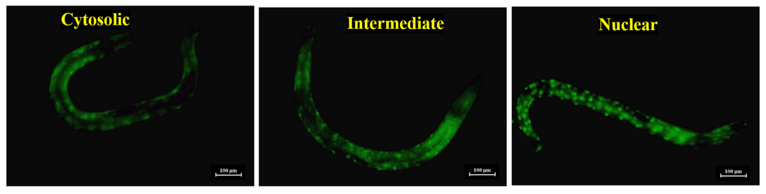
Figure 1 Three types of DAF-16::GFP subcellular localization^{[1]}

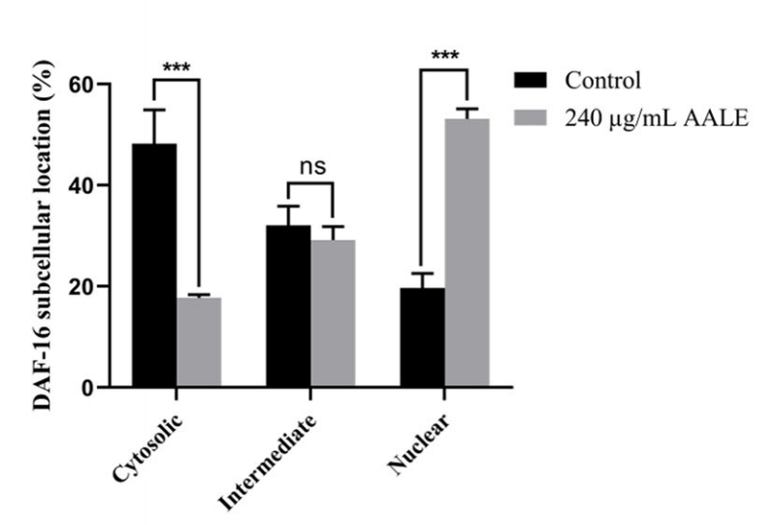
Figure 2 AALE treatment promotes the DAF-16::GFP transferring into the nucleus ^{[1]}
- Duration and Cost of the service
  - SUNY will conduct the DAF-16::GFP subcellular localization assay after SUNY get well cultured clean strains. The duration time is about 3-4 weeks as it will take at least one week to culture the starved worms for assay. SUNY will inform the client when SUNY begin and finish the assay.
  - The price of one/ three replicate(s) is $300/ $800 respectively for every strain/treatment. The final price would be $ for strains/ treatments for replicate(s).
  - SUNY will start the experiment after the client confirms the order. If the client needs to modify any order that has already been confirmed and started production, this may incur an additional charge.
- Results SUNY provide
  - The raw data of the photos of worms in each treatment.
  - The statistic data of DAF-16::GFP subcellular localization types in different treatments.
- How and when to pay
  - T/T (Telegraphic Transfer)
  - If it is client’s first time placing an order with SUNY and the total amount is no more than 3000 USD, no pre-payment is required. Otherwise, SUNY will require a pre-payment that equals to 50% of the total amount of client’s order prior to providing the service.
- Reference
- Jinsong, Wang,Deyan, Zhu,Hailin, Cui et al. Molecular mechanism of culinary herb Artemisia argyi in promoting lifespan and stress tolerance.[J] .NPJ Sci Food, 2024, 8: 0.

