Order of SNP chromosome mapping service
Date: Jan 18, 2022
NO.: 202201
- Information from the client
Table 1 Information from the client
Name: |  | Institute/ university:
PI (If different from above): |  | Department:
Tel: |  | E-mail:
Delivery Address:
Billing Address (If different from above):
Is the client willing to share his/her name, lab, and email address with SUNY’s future clients if they inquire? _______
How did the client learn about SunyBiotech? _________
- Email B) Mail C) Website D) From colleagues or friends
E) Other
(If the client chooses D, please write down the referrer name and institute and SUNY will apply 5% OFF to both the client and the client’s referrer. But please kindly note the 5% OFF is only applicable when the referrer comes from other labs.)
- About this service
This service includes PCR amplification with a set of 48 pair of primers that flank SNPs and evenly space among the six C. elegans chromosomes, restriction enzyme digestion to genotype the SNP sites, finding out the linkage position of the target mutation.
- Information about the mutant
  - Strain name and genotype: . Please also send the client’s wild type CB4856 if it is different from SUNY’s.
  - Phenotype of the strain: .
  - Culture temperature: .
  - Please provide the molecular information of the allele in sequence information part if it is not available on the WormBase.
- Method/ protocol
  - Typically 30 independent mutants from the heterozygotes that have been outcrossed with the CB4856 are lysed, respectively. Mix the same volume of these 30 templates together as the templates of the mutant strain, and label it as “P”.
  - Wild-type N2 and CB4856 animals are lysed, respectively. Mix the N2 lysis and CB4856 lysis (in a ratio of 1:2) together as the templates of the control strain, and label it as “C”.
  - Amplify the “P” and “C” samples with a set of 48 pair of primers, digest with DraI restriction emzyme for genotyping.
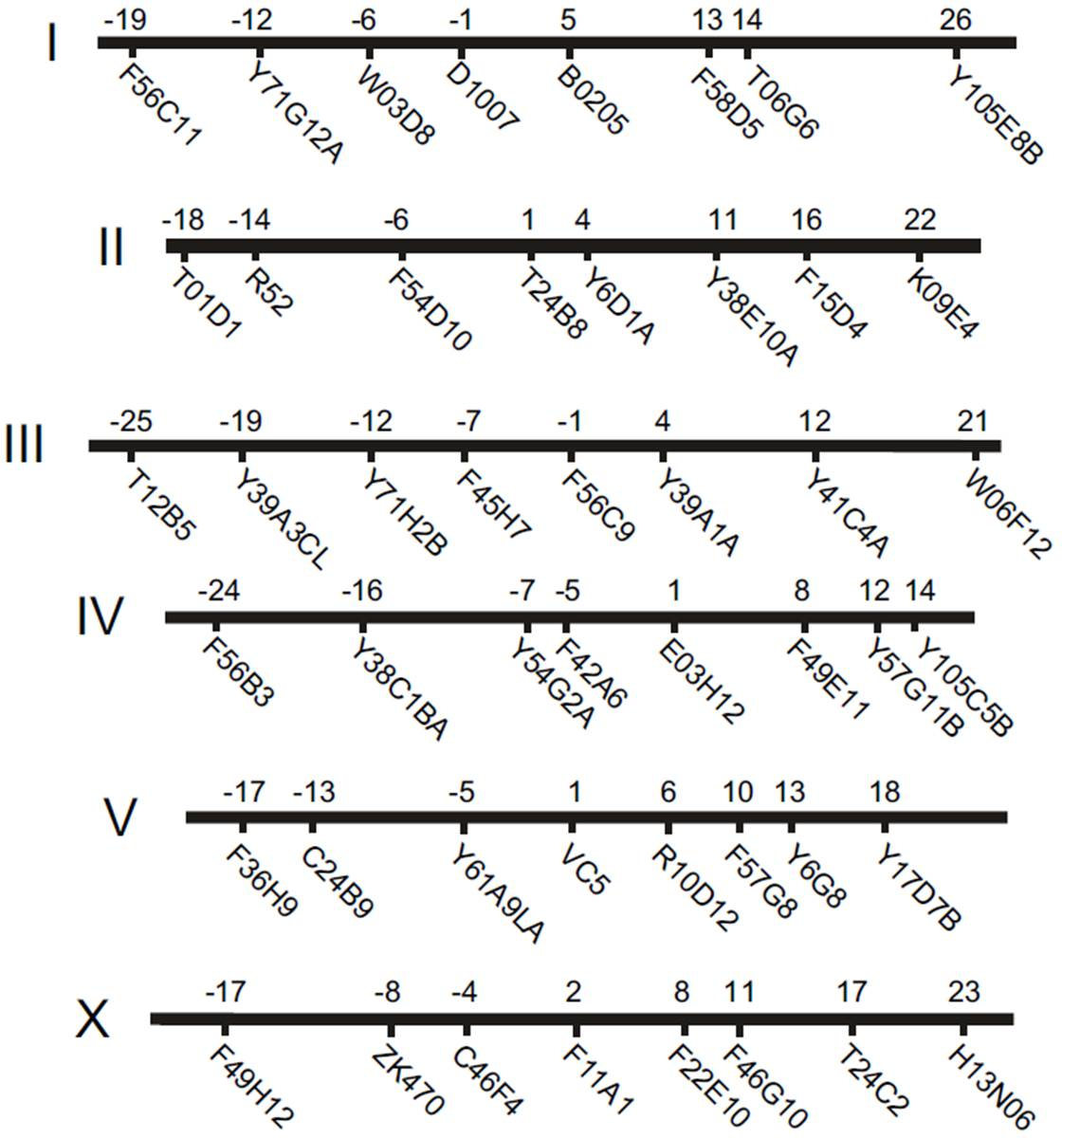
Figure 1 Genetic position of SNPs used for mapping
  - Analyze the result to map the mutation.

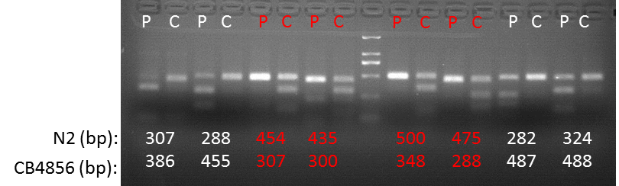
Figure 2 Partial of genotyping results (The linkage appears from -5 to +10)
- Duration and Cost of the service
  - It will take about 2 weeks to finish the SNP chromosome mapping.
  - Turnaround time is defined as the time from when an order is confirmed to when it is shipped. It does not include waiting time for any materials that the client needs to supply.
  - The price for the SNP chromosome mapping is $600.
  - SUNY will start the experiment after the client confirms the order. If the client needs to modify any order that has already been confirmed and started production, this may incur an additional charge.
  - SUNY will charge $40 USD shipping & handling fee for one order, and will apply 3.5% tax to each order.
- Products SUNY provide
  - Gel figures of SNP mapping.
- How and when to pay
  - T/T (Telegraphic Transfer)
  - If it is client’s first time placing an order with SUNY and the total amount is no more than 3000 USD, no pre-payment is required. Otherwise, SUNY will require a pre-payment that equals to 50% of the total amount of client’s order prior to providing the service.
- Reference
- M Wayne Davis, Marc Hammarlund, Tracey Harrach, Patrick Hullett, Shawn Olsen and Erik M Jorgensen. Rapid single nucleotide polymorphism mapping in C. elegans. BMC Genomics 2005, 6:118. doi:10.1186/1471-2164-6-118.

