Order of the Plasmid Construction
Date: Jan 18, 2022
NO.: 202201
- Information from the client
Table 1 Information from the client
Name: |  | Institute/ university:
PI (If different from above): |  | Department:
Tel: |  | E-mail:
Delivery Address:
Billing Address (If different from above):
Is the client willing to share his/her name, lab, and email address with SUNY’s future clients if they inquire? _______
How did the client learn about SunyBiotech? _________
- Email B) Mail C) Website D) From colleagues or friends
E) Other
(If the client chooses D, please write down the referrer name and institute and SUNY will apply 5% OFF to both the client and the client’s referrer. But please kindly note the 5% OFF is only applicable when the referrer comes from other labs.)
- Information about the vector backbone
SUNY usually use pPD49.78, pPD49.83, pSL1190, pPD95.77, pPD52.102, pCFJ151, pCFJ350, pCFJ352, pCFJ356, pCFJ909 as the vector backbone to make plasmid. If the client wants to use any of these vector backbones, please fill up the name in Table 2. If SUNY does not have the specific vector backbone the client requires, please complete Table 2 and provide the specific vector backbone.
Table 2 Features of the vector backbone
Name | Resistance | Host strain | Culture temperature
- Information about the insert (promoter/ target gene/3’UTR)
Table 3 Features of the Insert
Items |  | Description
Promoter | name
Promoter | length
Target gene with/without tag (GFP/RFP, etc) | name
Target gene with/without tag (GFP/RFP, etc) | length
Target gene with/without tag (GFP/RFP, etc) | cDNA or  genomic DNA
3’UTR | name
3’UTR | length
Please complete the Table 3 or provide sequence of promoter/ target gene/ 3’UTR in the sequence information part.
Please find the coding sequences of fluorescent proteins, tags or other insertions SUNY has in the following linker.
https://view.officeapps.live.com/op/view.aspx?src=https%3A%2F%2Fwww.sunybiotech.com%2Fuploadfile%2F1%2Fproduct%2F1d152e1711.xlsx&wdOrigin=BROWSELINK
- Duration and Cost of the service
  - It will take about weeks to finish the plasmid construction. SUNY may have to extend the turnaround time in the following conditions: poly A or poly T stretch affects the sequencing and amplification of the fragment, bad amplification of the fragment in promoter and 3’UTR region, and other technique difficulties. SUNY will inform the client if the turnaround time needs to be extended.
  - Turnaround time is defined as the time from when an order is confirmed to when it is shipped. It does not include waiting time for any materials that the client needs to supply.
  - Upon receipt of the plasmid that client sent to SUNY, SUNY will directly use it to start the related experiment. Client is responsible for providing the right plasmid and ensuring all information is correct. If it is turned to be wrong after the experiment is started, resulting in failure of experiment, there may be additional costs incurred for SUNY's extra work and client should cover the fee of it. During the verification, SUNY will charge $25 for one sequencing reaction (including primer design, primers synthesis, sequencing, sorting of sequence files, etc.).
  - The price is dependent on the length of the insert. bp sequence will be inserted into the . So the price for this order would be $ .
  - Once the sequence length exceeds 10,000bp, the additional cost will be $200 for every 1000bp length increase. That means $1700 for 11,000bp insertion, $1900 for 12,000bp insertion.
  - Once the sequence length exceeds 20,000bp, the additional cost will be $300 for every 1000bp length increase. That means $3800 for 21,000bp insertion, $4100 for 22,000bp insertion.
Table 4 Prices for sub-clone
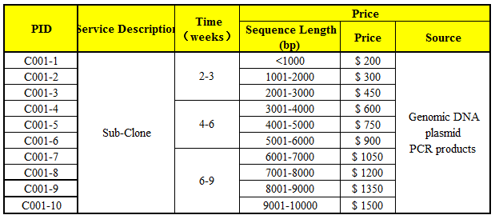
  - SUNY will start the experiment after the client confirms the order. If the client needs to modify any order that has already been confirmed and started production, this may incur an additional charge.
  - SUNY will charge $40 USD shipping & handling fee for one order, and will apply 3.5% tax to each order.
- Products SUNY provide
  - The final products would be plasmid and the sequencing reports.
  - The construct would be . (for example: Psap-1::sap-1::cherry::unc-54 3’UTR).
- How and when to pay
  - T/T (Telegraphic Transfer)
  - If it is client’s first time placing an order with SUNY and the total amount is no more than 3000 USD, no pre-payment is required. Otherwise, SUNY will require a pre-payment that equals to 50% of the total amount of client’s order prior to providing the service.
- Sequences information (required)
  - Sequence of vector backbone:

  - Inserted sequence:

  - Sequence of final target plasmid:

