Order of Fatty acid composition Assay
Date： Jan 18th, 2018
NO.: 20180118
- Information from the client
Table 1 Information from the client
Name: |  | Institute/ university:
PI (If different from above): |  | Department：
Tel: |  | E-mail:
Delivery Address:
Billing Address (If different from above):
Is the client willing to share his/her name, lab, and email address with SUNY’s future clients if they inquire? _______
How did the client learn about SunyBiotech? _________
- Email B) Mail C) Website D) From colleagues or friends
E) Other
(If the client chooses D, please write down the referrer name and institute and SUNY will apply 5% OFF to both the client and the client’s referrer. But please kindly note the 5% OFF is only applicable when the referrer comes from other labs.)
- About this assay
The purpose of this assay is to measure the 37 fatty acids in worms. For every treatment/ sample, 200,000 worms are collected and three assays will be conducted.
- Information about the tested strain and drug
  - Please complete the strain information including strain name, genotype, phenotype and culture condition in the below Table 2.
  - If the clients want to treat the worms with specific drugs, please complete the Table 3.
  - Please send all strains/drugs to Sunybiotech. If client’s wild type N2 strain is used as control, please also include the wild type N2 strain when sending strains to SUNY.
  - Is the drug sterilized or not? ( for example: yes, no). If not, please provide the sterilization method . If the syringe driven filtration is required, please choose the pore size of the syringe driven filter (0.22µm or 0.45µm).
  - The drug should be added into for C. elegans culturing. (for example: NGM, OP50).
Table 2 Information of the tested strains
Strain name | Genotype | Phenotype | Culture condition
Table 3 Information about the drugs
 | Drug name/ NO. | Concentration of the stock | Storage condition | Solvent | working concentration | working volume
1
2
3
4
- Method/ protocol
Prepare NGM plates
  - Prepare NGM plates supplemented with FUDR (if it is needed) and drug with different concentrations. Plates are seeded with 10 times concentrated OP50 after plates are solidified.
  - Prepare typical NGM plate seeds with OP50.
Prepare synchronized animals
  - Prepare the synchronized eggs of control and experimental groups, culture the eggs in the 20 °C incubator. The drug treatment begins at the egg stage.
  - Synchronized egg development into young adult ? stage (65 hours after egg growth). For every treatment/ sample, 200,000 worms are collected.
Fatty acid measurements
  - Worms were washed with M9 buffer to remove bacteria from the diet. The fatty acid were extracted with 1 mL of solvent (2% H₂SO₄ mixed with 98% methanol) at 80℃.
  - The fatty acid composition of worms was identified by GC-MS and compared with commercial fatty acid standards^{[1]}.
Representative results
  - Raw data of fatty acid content in each group of worms.
  - Analysis of raw data ( Figure 1).
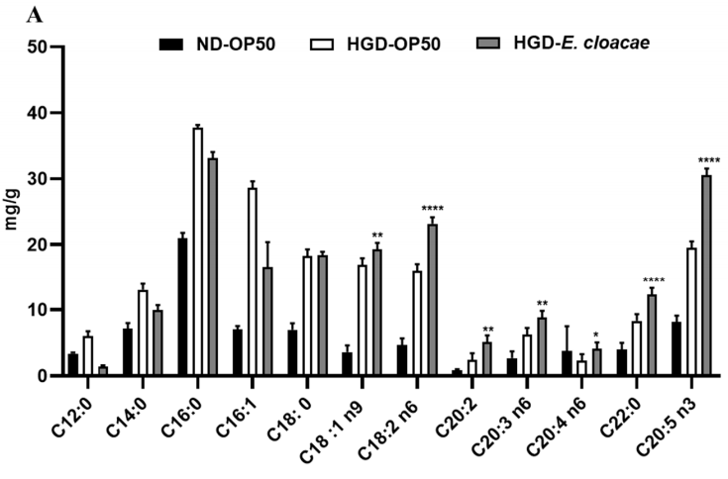
Figure 1 Fatty acid composition in worms

- Duration and Cost of the service
  - SUNY will conduct the assay after SUNY get well cultured clean strains (at least one week). The duration time is 3-4 weeks. SUNY will inform the client when SUNY begin and finish the assay.
  - The price of three assays for each treatment/sample is $1150 . The final price would be $ for treatments/samples.
  - SUNY will start the experiment after the client confirms the order. If the client needs to modify any order that has already been confirmed and started production, this may incur an additional charge.
- Results SUNY provide
  - Raw data of fatty acid content in each group of worms.
  - Analysis of raw data.
- How and when to pay
  - T/T (Telegraphic Transfer)
  - If it is client’s first time placing an order with SUNY and the total amount is no more than 3000 USD, no pre-payment is required. Otherwise, SUNY will require a pre-payment that equals to 50% of the total amount of client’s order prior to providing the service.
- Reference
[1] Gu Mingkun,Werlinger Pia,Cho Joo-Hyung et al. Lactobacillus pentosus MJM60383 Inhibits Lipid Accumulation in Induced by and Glucose.[J] .Int J Mol Sci, 2022, 24: undefined.

