Order of the Intestinal barrier assay
Date： Jan 18th, 2018
NO.: 20180118
- Information from the client
Table 1 Information from the client
Name: |  | Institute/ university:
PI (If different from above): |  | Department：
Tel: |  | E-mail:
Delivery Address:
Billing Address (If different from above):
Is the client willing to share his/her name, lab, and email address with SUNY’s future clients if they inquire? _______
How did the client learn about SunyBiotech? _________
- Email B) Mail C) Website D) From colleagues or friends
E) Other
(If the client chooses D, please write down the referrer name and institute and SUNY will apply 5% OFF to both the client and the client’s referrer. But please kindly note the 5% OFF is only applicable when the referrer comes from other labs.)
- About this assay
The purpose of this assay is to measure the intestinal barrier of worms with the food dye Brilliant Blue. For every treatment, one/ three replicate(s) will be conducted. For every/three replicate(s), 10/30 worms will be tested.
- Information about the tested strain and drug
  - Please complete the strain information including strain name, genotype, phenotype and culture condition in the below Table 2.
  - If the clients want to treat the worms with specific drugs, please complete the Table 3.
  - Please send all strains/drugs to Sunybiotech. If client’s wild type N2 strain is used as control, please also include the wild type N2 strain when sending strains to SUNY.
  - Is the drug sterilized or not? ( for example: yes, no). If not, please provide the sterilization method . If the syringe driven filtration is required, please choose the pore size of the syringe driven filter (0.22µm or 0.45µm).
  - The drug should be added into for C. elegans culturing. (for example: NGM, OP50).
Table 2 Information of the tested strains
Strain name | Genotype | Phenotype | Culture condition
Table 3 Information about the drugs
 | Drug name/ NO. | Concentration of the stock | Storage condition | Solvent | working concentration | working volume
1
2
3
4
- Method/ protocol
Prepare NGM plates
  - Prepare NGM plates supplemented with FUDR and drug with different concentrations. Plates are seeded with 10 times concentrated OP50 after plates are solidified.
  - Prepare typical NGM plate seeds with OP50.
Prepare synchronized animals
  - Prepare the synchronized eggs by collecting eggs from adults in one hour, culture the eggs in the 20 °C incubator.
  - The drug treatment begins at L4? stage.
Staining and Imaging
  - Transfer the worms to new NGM plates containing FUDR and the drug every 96 hours to prevent starvation and contamination.
  - 3, 7 days ？later, stain the worms with the food dye Brilliant Blue and photograph them ^{[1,2]}.
Experimental Data and Results Compilation
  - The pictures of worms (Figure 1) stained by the food dye Brilliant Blue will be provided.
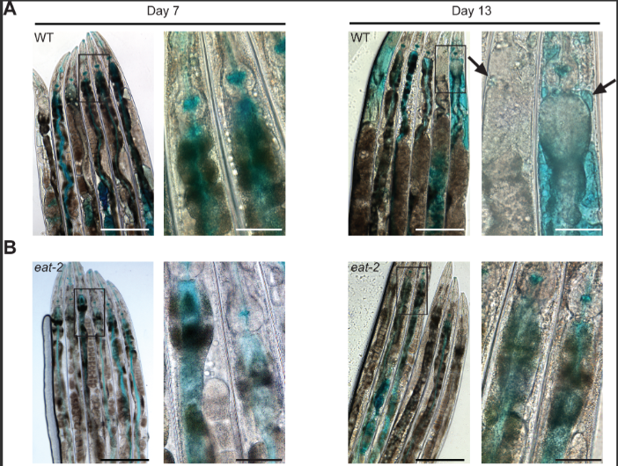
Figure 1 Worms stained by the food dye Brilliant Blue ^{[1]}
- Duration and Cost of the service
  - SUNY will conduct the assay after SUNY get well cultured clean strains (at least one week). The duration time is 3-4 weeks. SUNY will inform the client when SUNY begin and finish the assay.
  - The prices are related to the timing of staining and photoing. The price for staining and photoing on the day 3 and day 7 of one / three replicate(s) is $350 / $700 respectively for every strain/treatment. The final price would be $ for strains/treatments with replicates.
  - SUNY will start the experiment after the client confirms the order. If the client needs to modify any order that has already been confirmed and started production, this may incur an additional charge.
- Results SUNY provide
  - The pictures of worms stained by the food dye Brilliant Blue.
- How and when to pay
  - T/T (Telegraphic Transfer)
  - If it is client’s first time placing an order with SUNY and the total amount is no more than 3000 USD, no pre-payment is required. Otherwise, SUNY will require a pre-payment that equals to 50% of the total amount of client’s order prior to providing the service.
- Reference
- Sara, Gelino,Jessica T, Chang,Caroline, Kumsta et al. Intestinal Autophagy Improves Healthspan and Longevity in C. elegans during Dietary Restriction.[J] .PLoS Genet, 2016, 12: 0.
- Zekai, Wu,Jian, Zhang,Yajiao, Wu et al. Gelsenicine disrupted the intestinal barrier of Caenorhabditis elegans.[J] .Chem Biol Interact, 2024, 395: 0.

