Order of Heavy Metal Stress Assay
Date： Jan 18th, 2018
NO.: 20180118
- Information from the client
Table 1 Information from the client
Name: |  | Institute/ university:
PI (If different from above): |  | Department：
Tel: |  | E-mail:
Delivery Address:
Billing Address (If different from above):
Is the client willing to share his/her name, lab, and email address with SUNY’s future clients if they inquire? _______
How did the client learn about SUNY? _________
- Email B) Mail C) Website D) From colleagues or friends
E) Other
(If the client chooses D, please write down the referrer name and institute and SUNY will apply 5% OFF to both the client and the client’s referrer. But please kindly note the 5% OFF is only applicable when the referrer comes from other labs.)
- About this assay
The purpose of this assay is to determine the worm resistance to heavy metal stress. For every strain, one/ three replicate(s) will be conducted. For every/ three replicate(s), at least 10/ 30 worms will be tested.
- Information about the tested strain
  - Please complete the strain information including strain name, genotype, phenotype and culture condition in the below Table 2.
  - If the clients want to treat the worms with specific drugs, please complete the Table 3.
  - Please send all strains/drugs to Sunybiotech. If client’s wild type N2 strain is used as control, please also include the wild type N2 strain when sending strains to SUNY.
  - Is the drug sterilized or not? ( for example: yes, no). If not, please provide the sterilization method . If the syringe driven filtration is required, please choose the pore size of the syringe driven filter (0.22µm or 0.45µm).
  - The drug should be added into for C. elegans culturing. (for example: NGM, OP50).
Table 2 Information of the tested strains
Strain name | Genotype | Phenotype | Culture condition
PHX9545 | sybIs9463 [Pnumr-1-numr-1-GFP+rol-6(su1006)] |  | 20℃
Table 3 Information about the drugs
 | Drug name/ NO. | Concentration of the stock | Storage condition | Solvent | working concentration | working volume
1
2
3
4
- Method/ protocol
Prepare synchronized animals
  - Prepare the synchronized eggs by collecting eggs from adults in 1-4 hour, culture the eggs in the 20 °C incubator.
  - The drug treatment begins at L4? stage.
  - The heavy metal treatment begins at L4 stage.
  - Adding the proper amount of heavy metal solution and FUDR to M9 buffer.
Resistance to heavy metal stress
  - 24 hours later, photo the worms with the same exposure time in GFP channel.
  - Measure the amount of the fluorescence with Image J software.
Representative results
  - The raw data of the photos of different treatments (Figure 1).
  - Fluorescence intensity quantified by ImageJ2 (Figure 2).
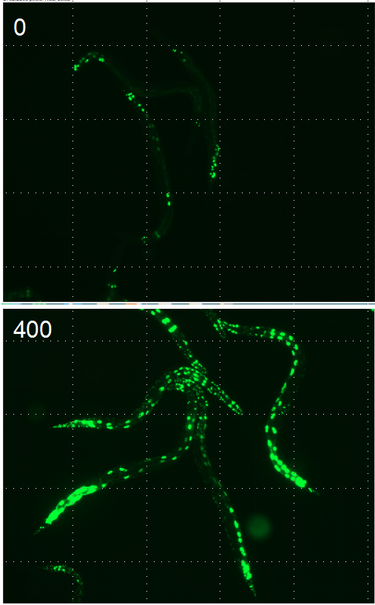
Figure 1 PHX9454 worms treated with 400 µM potassium dichromate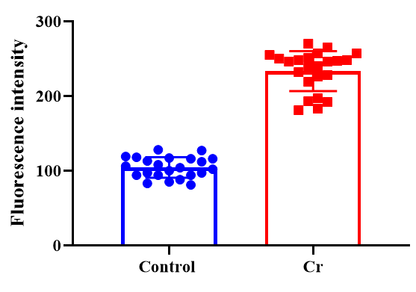
Figure 2 Fluorescence intensity quantified
- Duration and Cost of the service
  - The duration time is 2-3 weeks. SUNY will conduct the assay after get well cultured clean strains (at least one week). SUNY will inform the client when SUNY begin and finish the assay.
  - The price for one / three replicate (s) is $300 / $600 respectively for every strain/treatment. The price for this order would be for strains/ treatments for replicate(s).
  - SUNY will start the experiment after the client confirms the order. If the client needs to modify any order that has already been confirmed and started production, this may incur an additional charge.
- Results SUNY provide
  - The raw data: SUNY will provide the picture of worms for each group tested .
  - Fluorescence intensity quantified by ImageJ2.
- How and when to pay
  - T/T (Telegraphic Transfer)
  - If it is client’s first time placing an order with SUNY and the total amount is no more than 3000 USD, no pre-payment is required. Otherwise, SUNY will require a pre-payment that equals to 50% of the total amount of client’s order prior to providing the service.
- Reference
[1] Brooke E, Tvermoes,Windy A, Boyd,Jonathan H, Freedman,Molecular characterization of numr-1 and numr-2: genes that increase both resistance to metal-induced stress and lifespan in Caenorhabditis elegans.[J] .J Cell Sci, 2010, 123: 0.

