Order of Lifespan Assay
Date： Jan 18th, 2018
NO.: 20180118
- Information from the client
Table 1 Information from the client
Name: |  | Institute/ university:
PI (If different from above): |  | Department：
Tel: |  | E-mail:
Delivery Address:
Billing Address (If different from above):
Is the client willing to share his/her name, lab, and email address with SUNY’s future clients if they inquire? _______
How did the client learn about SunyBiotech? _________
- Email B) Mail C) Website D) From colleagues or friends
E) Other
(If the client chooses D, please write down the referrer name and institute and SUNY will apply 5% OFF to both the client and the client’s referrer. But please kindly note the 5% OFF is only applicable when the referrer comes from other labs.)
- About this assay
The purpose of this assay is to compare the lifespan of different strains. For every strain, one/ three replicate(s) will be conducted. For one/ three replicate(s), at least 100/ 300 worms will be tested, and the data of 80/240 worms will be provided.
- Information about the tested strains
  - Please complete the strain information including strain name, genotype, phenotype and culture condition in the below Table 2.
  - If the clients want to treat the worms with specific drugs, please complete the Table 3.
  - Please send all strains/drugs to Sunybiotech. If client’s wild type N2 strain is used as control, please also include the wild type N2 strain when sending strains to SUNY.
  - Is the drug sterilized or not? ( for example: yes, no). If not, please provide the sterilization method . If the syringe driven filtration is required, please choose the pore size of the syringe driven filter (0.22µm or 0.45µm).
  - The drug should be added into for C. elegans culturing. (for example: NGM, OP50).
Table 2 Information about the strains
Strain name | Genotype | Phenotype | Culture condition
Table 3 Information about the drugs
 | Drug name/ NO. | Concentration of the stock | Storage condition | Solvent | working concentration | working volume
1
2
3
4
- Method/ protocol
Prepare NGM plates
  - Prepare NGM plates supplemented with FUDR and drug with different concentrations. Plates are seeded with 10 times concentrated OP50 after plates are solidified.
  - Prepare typical NGM plate seeds with OP50.
Prepare synchronized animals
  - Prepare the synchronized eggs by collecting eggs from adults in one hour, culture the eggs in the 20 °C incubator.
  - The drug treatment begins at L4? stage.
Score animals for lifespan
  - Record the date and the number of worms that are dead/matricide every other day until all worms die. Animals are considered dead when no movement or pharyngeal pumping is observed after gentle touch to the head.
  - Transfer worms to NGM plates with FUDR and drug every 96h to avoid the contamination and starvation.
  - Worms that crawl out of plates will not be counted.
Representative results
  - For the raw data (Figure 1), a list of dates with corresponding numbers of worms dead will be provided.
  - For the survival curve (Figure 2), the day of the synchronized L4 is considered day 0. The total number test in every assay is the sum of worms die in every assay.
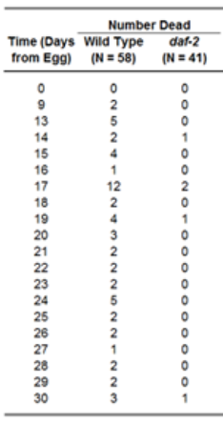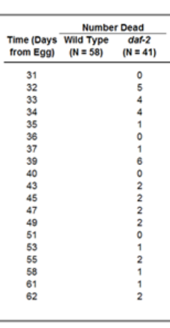
Figure 1 Raw data from a C. elegans lifespan experiment comparing wild type strain N2 to a daf-2 mutant^{[1]}
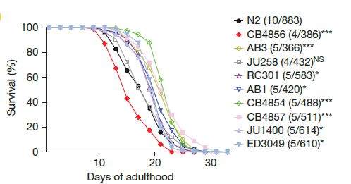
Figure 2 Survival curve from a C. elegans lifespan experiment comparing wild type N2 and other strains^{[2]}
- Duration and Cost of the service
  - SUNY will conduct the lifespan assay after get well cultured clean animals. The duration time is dependent on the lifespan of each strain. Usually 6-8 weeks is enough. SUNY will inform client when SUNY begin and finish the assay.
  - The price of one / three replicate(s) is $300 / $800 respectively for every strain/treatment. The final price would be for strains/treatments with replicate(s).
  - SUNY will start the experiment after the client confirms the order. If the client needs to modify any order that has already been confirmed and started production, this may incur an additional charge.
- Products SUNY provide
  - Raw data of every strain/ treatment.
  - Survival curve of every strain.
- How and when to pay
  - T/T (Telegraphic Transfer)
  - If it is client’s first time placing an order with SUNY and the total amount is no more than 3000 USD, no pre-payment is required. Otherwise, SUNY will require a pre-payment that equals to 50% of the total amount of client’s order prior to providing the service.
- Reference
[1] Sutphin G.L., Kaeberlein M.. Measuring Caenorhabditis elegans Life Span on Solid Media. JoVE. 2009. 27:1152-1168
[2] Yin JA, Gao G, Liu XJ, Hao ZQ, Li K, Kang XL, Li H, Shan YH, Hu WL, Li HP, Cai SQ. Genetic variation in glia–neuron signalling modulates ageing rate. Nature. 2017. 551:198-203.

