Order of Tri-Glyceride content Assay
Date： Nov 5, 2021
NO.: 2021110501
- Information from the client
Table 1 Information from the client
Name: |  | Institute/ university:
PI (If different from above): |  | Department：
Tel: |  | E-mail:
Delivery Address:
Billing Address (If different from above):
Is the client willing to share his/her name, lab, and email address with SUNY’s future clients if they inquire? _______
How did the client learn about SunyBiotech? _________
- Email B) Mail C) Website D) From colleagues or friends
E) Other
(If the client chooses D, please write down the referrer name and institute and SUNY will apply 5% OFF to both the client and the client’s referrer. But please kindly note the 5% OFF is only applicable when the referrer comes from other labs.)
- About this assay
The purpose of this assay is to measure the triglyceride content of worms after chemical treatment. For every strain, one/three replicate(s) will be conducted. For every/ three replicate(s), at least 3000/ 9000 worms will be tested.
- Information about the tested strains
  - Please complete the strain information including strain name, genotype, phenotype and culture condition in the below Table 2.
  - If the clients want to treat the worms with specific drugs, please complete the Table 3.
  - Please send all strains/drugs to Sunybiotech. If client’s wild type N2 strain is used as control, please also include the wild type N2 strain when sending strains to SUNY.
  - Is the drug sterilized or not? ( for example: yes, no). If not, please provide the sterilization method . If the syringe driven filtration is required, please choose the pore size of the syringe driven filter (0.22µm or 0.45µm).
  - The drug should be added into for C. elegans culturing. (for example: NGM, OP50).
Table 2 Information about the strains
Strain name | Genotype | Phenotype | Culture condition
Table 3 Information about the drugs
 | Drug name/ NO. | Concentration of the stock | Storage condition | Solvent | working concentration | working volume
1
2
3
4
- Method/ protocol
Prepare NGM plates
  - Prepare NGM plates supplemented with FUDR and drug with different concentrations. Plates are seeded with 10 times concentrated OP50 after plates are solidified.
  - Prepare typical NGM plate seeds with OP50.
Prepare synchronized animals
  - Prepare the synchronized L1s by bleaching, culture the L1s in the 20 °C incubator.
  - The drug treatment begins at L4? stage.
Worm collection and triglyceride content assay
  - Transfer the worms to new NGM plates with FUDR and drug every 96 hours to avoid starve and contamination.
  - X days later, collect the worms with M9, sonicate it and the supernatant is used for triglyceride content assay.
  - The content of triglyceride of C. elegans are determined using assay kit according to the manufacturer’s instructions.
Representative results
  - The raw data of the triglyceride content of different treatments.
  - The statistic data of different treatments (Figure 1).
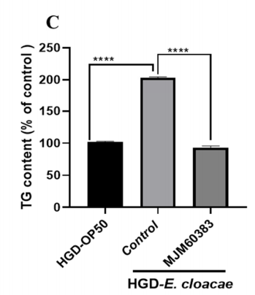
Figure 1 The statistic analysis of the triglyceride content^{[1]}
- Duration and Cost of the service
  - SUNY will conduct the triglyceride content assay after SUNY get well cultured clean strains. The duration time is about 3-4 weeks as it will take at least one week to culture the starved worms for assay.
  - The price of one/ three replicate(s) is $450/ $1200 respectively for every strain/treatment. The final price would be $ for strains/ treatments for replicate(s).
  - SUNY will start the experiment after the client confirms the order. If the client needs to modify any order that has already been confirmed and started production, this may incur an additional charge.
- Results SUNY provide
  - The raw data of the TG content of different treatments.
  - The statistic data of different treatments.
- How and when to pay
  - T/T (Telegraphic Transfer)
  - If it is client’s first time placing an order with SUNY and the total amount is no more than 3000 USD, no pre-payment is required. Otherwise, SUNY will require a pre-payment that equals to 50% of the total amount of client’s order prior to providing the service.
- Reference
[1] Gu Mingkun,Werlinger Pia,Cho Joo-Hyung et al. Lactobacillus pentosus MJM60383 Inhibits Lipid Accumulation in Induced by and Glucose.[J] .Int J Mol Sci, 2022, 24: undefined.

