Order of α-Synuclein Accumulation measurement
Date： Feb7, 2022
NO.: 2022020701
- Information from the client
Table 1 Information from the client
Name: |  | Institute/ university:
PI (If different from above): |  | Department：
Tel: |  | E-mail:
Delivery Address:
Billing Address (If different from above):
Is the client willing to share his/her name, lab, and email address with SUNY’s future clients if they inquire? _______
How did the client learn about SunyBiotech? _________
- Email B) Mail C) Website D) From colleagues or friends
E) Other
(If the client chooses D, please write down the referrer name and institute and SUNY will apply 5% OFF to both the client and the client’s referrer. But please kindly note the 5% OFF is only applicable when the referrer comes from other labs.)
- About this assay
The purpose of this assay is to measure the accumulation of α-Synuclein. For every strain, one/three replicate(s) will be conducted. For every/ three replicate(s), at least 10/ 30 worms will be tested.
- Information about the tested strains
  - Please complete the strain information including strain name, genotype, phenotype and culture condition in the below Table 2.
  - If the clients want to treat the worms with specific reagents, please complete the Table 3.
  - Please send all strains/ reagents to SUNY. If client’s wild type N2 strain is used as control, please also include the wild type N2 strain when sending strains to SUNY.
  - Is the drug sterilized or not? ( for example: yes, no). If not, please provide the sterilization method . If the syringe driven filtration is required, please choose the pore size of the syringe driven filter (0.22µm or 0.45µm).
  - The drug should be added into for C. elegans culturing. (for example: NGM, OP50)
Table 2 Information about the strains
Strain name | Genotype | Phenotype | Culture condition
Table 3 Information about the reagents
 | Drug name/ NO. | Concentration of the stock | Storage condition | Solvent | working concentration
1
2
3
4
- Method/ protocol
Prepare NGM plates
  - Prepare typical NGM plate and NGM plate with XX (drug) of different concentrations/L-dopa with or without FUDR.
  - Plates without the FUDR are seeded with OP50, plates with FUDR are seeded with 10 times concentrated OP50 after plates are solidified.
  - Store these plates upside down at 4 °C.
Prepare synchronized animals
  - The drug treatment begins at egg stage.
  - Prepare the synchronized eggs by collecting eggs from adults in one hour on the NGM plates with XX (drug) of different concentrations/L-dopa, culture the eggs in the 20 °C incubator until the worms are at L4 stage.
  - Transfer the synchronized L4 worms to new NGM plates with FUDR and XX (drug) of different concentrations/L-dopa.
Observe and measure α-Synuclein accumulation
  - 5 days after L4 (7 days after L1), the α-Synuclein accumulation measurement assay will be conducted.
  - Photo the worms with the same exposure time in GFP channel.
  - Measure the amount of the fluorescence of the α-Synuclein accumulation with Image J software.
Representative results
  - The raw data of the photos of all worms (Figure 1).
  - The statistic data of different treatments (Figure 2).
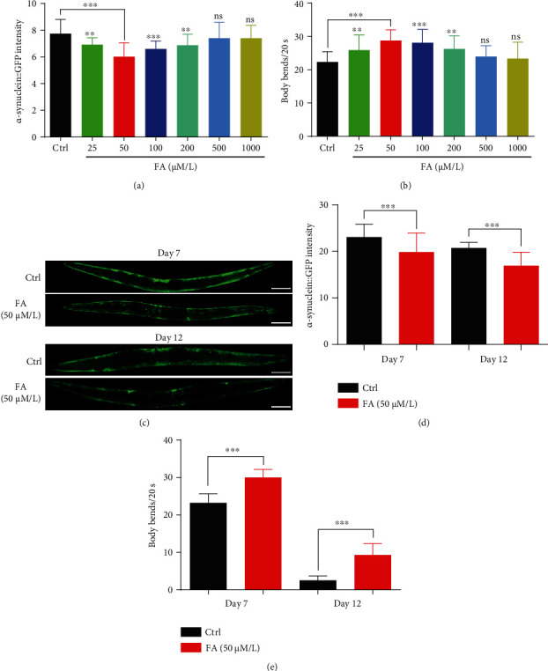
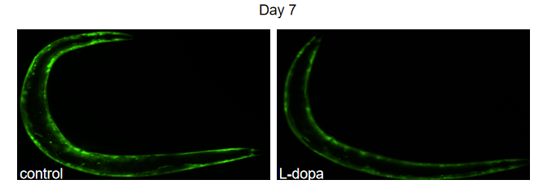
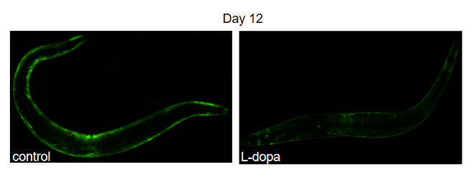

Figure 1 The fluorescence of the α-Synuclein accumulation^{[1]}
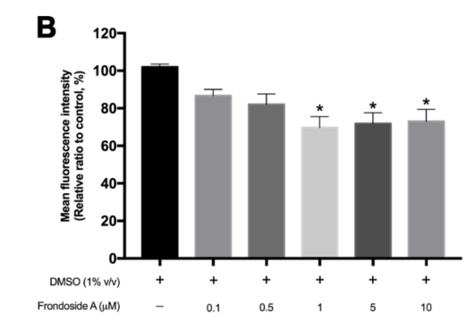
Figure 2 The statistic analysis of the fluorescence of α-Synuclein in NL5901 ^{[2]}
- Duration and Cost of the service
  - SUNY will conduct the α-Synuclein Accumulation measurement assay after SUNY get well cultured clean strains. The duration time is about 3-4 weeks as it will take at least one week to culture the starved worms for assay.
  - The price of one/ three replicate(s) is $400 / $800 respectively for every strain/treatment. The final price would be $ for strains/ treatments for replicate(s).
  - SUNY will start the experiment after the client confirms the order. If the client needs to modify any order that has already been confirmed and started production, this may incur an additional charge.
- Results SUNY provide
  - The raw data of the photos of all worms.
  - The statistic data of different treatments.
- How and when to pay
  - T/T (Telegraphic Transfer)
  - If it is client’s first time placing an order with SUNY and the total amount is no more than 3000 USD, no pre-payment is required. Otherwise, SUNY will require a pre-payment that equals to 50% of the total amount of client’s order prior to providing the service.
- Reference
- Chalorak P, Sanguanphun T, Limboonreung T, et al. Neurorescue Effects of Frondoside A and Ginsenoside Rg3 in C. elegans Model of Parkinson’s Disease[J]. Molecules, 2021, 26(16): 4843.
- Long T, Wu Q, Wei J, et al. Ferulic acid exerts neuroprotective effects via autophagy induction in C. elegans and cellular models of Parkinson’s disease[J]. Oxidative Medicine and Cellular Longevity, 2022.

