Order of Food clearance assay
Date： Sep 29, 2021
NO.: 202109
- Information from the client
Table 1 Information from the client
Name: |  | Institute/ university:
PI (If different from above): |  | Department：
Tel: |  | E-mail:
Delivery Address:
Billing Address (If different from above):
Is the client willing to share his/her name, lab, and email address with SUNY’s future clients if they inquire? _______
How did the client learn about SunyBiotech? _________
- Email B) Mail C) Website D) From colleagues or friends
E) Other
- About this assay
The purpose of this assay is to compare the efficiency of food clearance of C. elegans in solution with treatment of three different concentration of drug sample, by measuring the absorbance (O.D.595 nm) of the solution for six days. For every concentration, three replicates will be conducted. For three replicate(s), 450 synchronized worms will be cultured for the test.
- Information about the tested strains
  - Please complete the strain information including strain name, genotype, phenotype and culture condition in the below Table 2.
  - If the clients want to treat the worms with specific drugs, please complete the Table 3. The drugs will be added into the liquid culture solution.
  - Please send all strains/ drugs to SunyBiotech. If client’s wild type N2 strain is used as control, please also include the wild type N2 strain when sending strains to SUNY.
  - Is the drug sterilized or not? ( for example: yes, no). If not, please provide the sterilization method . If the syringe driven filtration is required, please choose the pore size of the syringe driven filter (0.22µm or 0.45µm).
Table 2 Information about the strains
Strain name | Genotype | Phenotype | Culture condition
N2 | Wild type | Wild type | 20°C
Table 3 Information about the drugs
 | Drug name/ NO. | Concentration of the stock | Storage condition | Solvent | working concentration
1
2
3
4
- Method/ protocol
Prepare 24-well plates
  - The total volume of liquid culture solution for each well will be the same.
  - Prepare M9 liquid culture solution with same volume of overnight cultured OP50, FUDR and the drug with different concentrations.
Prepare synchronized animals
  - Prepare the synchronized eggs by collecting eggs from adults in 4 hours, culture the eggs in the 20 °C incubator.
  - After synchronized worms are at L4 stage, wash and clean the worms with M9 solution, suspend the worm pellet with M9 supplemented with FUDR.
  - Add the same volume the worms to the above liquid culture solution. .
  - Shake the 24-well plates in the 20 °C incubator.
Analyze the absorbance (O.D.595nm)
  - For every well (every replicate of each treatment), measure and record the O.D.595 nm with spectrophotometer (Eppendorf D30) every 24 hours for 6 days (From day0 to day5)
Representative results
  - The raw data of OD595 of E. coli (OP50) of each worm liquid culture well after treated with different concentration of drug.
  - Statistical data of the absorbance (O.D.595 nm) of different treatment.

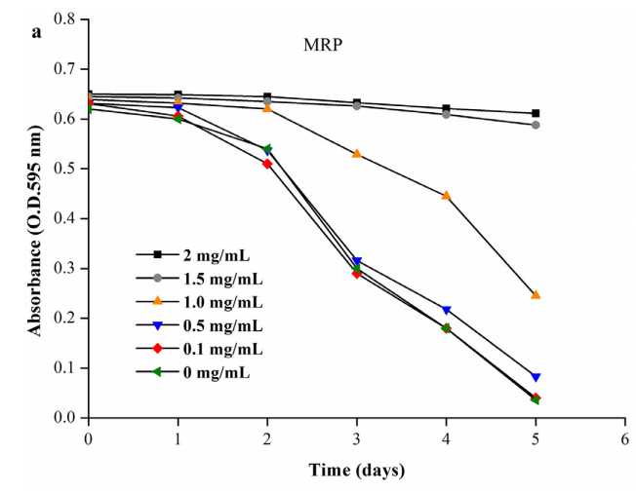
Figure 1. The OD of E. coli is reported daily for each concentration of Polysaccharide
- Duration and Cost of the service
  - SUNY will conduct the food clearance assay after getting well-cultured clean animals. The duration time is dependent on the duration of animal synchronization and the procedure of experiment. Usually 2-4 weeks are enough. SUNY will inform client when SUNY begin and finish the assay.
  - The price for this assay is $800 for one strain/ one drug with three different concentrations and a control group without drug added.
  - SUNY will start the experiment after the client confirms the order. If the client needs to modify any order that has already been confirmed and started production, this may incur an additional charge.
- Products SUNY provide
  - The raw data of OD595 of E. coli (OP50) of each worm liquid culture well after treated with different concentration of drug.
  - Statistical data of the absorbance (O.D.595 nm) of different treatment.
- How and when to pay
  - T/T (Telegraphic Transfer)
  - If it is client’s first time placing an order with SUNY and the total amount is no more than 3000 USD, no pre-payment is required. Otherwise, SUNY will require a pre-payment that equals to 50% of the total amount of client’s order prior to providing the service.
- Reference
[1] Feng, S., Cheng, H., Xu, Z., Shen, S., Yuan, M., Liu, J. and Ding, C., 2021. Thermal stress resistance and aging effects of Panax notoginseng polysaccharides on Caenorhabditis elegans.

