Order of Oxidative Stress assay
Date： Jan 18th, 2018
NO.: 20180118
- Information from the client
Table 1 Information from the client
Name: |  | Institute/ university:
PI (If different from above): |  | Department：
Tel: |  | E-mail:
Delivery Address:
Billing Address (If different from above):
Is the client willing to share his/her name, lab, and email address with SUNY’s future clients if they inquire? _______
How did the client learn about SUNY? _________
- Email B) Mail C) Website D) From colleagues or friends
E) Other
(If the client chooses D, please write down the referrer name and institute and SUNY will apply 5% OFF to both the client and the client’s referrer. But please kindly note the 5% OFF is only applicable when the referrer comes from other labs.)
- About this assay
The purpose of this assay is to measure the worm’s sensitivity to oxidative stress. For every strain, one/ three replicate(s) will be conducted. For every/ three replicate(s), at least 80/ 240 worms will be tested, and the data of 67/200 worms will be provided.
- Information about the tested strain
  - Please complete the strain information including strain name, genotype, phenotype and culture condition in the below Table 2.
  - If the clients want to treat the worms with specific drugs, please complete the Table 3.
  - Please send all strains/drugs to Sunybiotech. If client’s wild type N2 strain is used as control, please also include the wild type N2 strain when sending strains to SUNY.
  - Is the drug sterilized or not? ( for example: yes, no). If not, please provide the sterilization method . If the syringe driven filtration is required, please choose the pore size of the syringe driven filter (0.22µm or 0.45µm).
  - The drug should be added into for C. elegans culturing. (for example: NGM, OP50).
Table 2 Information of the tested strains
Strain name | Genotype | Phenotype | Culture condition
Table 3 Information about the drugs
 | Drug name/ NO. | Concentration of the stock | Storage condition | Solvent | working concentration | working volume
1
2
3
4
- Method/ protocol
Prepare NGM plates
  - Prepare NGM plates supplemented with FUDR and drug with different concentrations. Plates are seeded with 10 times concentrated OP50 after plates are solidified.
  - Prepare NGM plate supplemented with FUDR, drug with different concentrations and 40 mM paraquat (Sigma) or 240 mM juglone (Sigma). Plates are seeded with 10 times concentrated OP50 after plates are solidified.
  - Prepare typical NGM plate seeds with OP50.
Prepare synchronized animals
  - Prepare the synchronized eggs by collecting eggs from adults in one hour, culture the eggs in the 20 °C incubator.
  - The drug treatment begins at L4? stage.
  - X days later, transfer worms to the new NGM plates with FUDR, drug, juglone/ paraquat, and put all these plates at the same 20 °C incubator.
Measuring sensitivity to oxidative stress
  - For juglone/ paraquat treatment assay, record the time and the number of worms that are dead hourly/daily until the worms treated with juglone/ paraquat are all dead.
  - Animals are considered dead when no movement or pharyngeal pumping is observed after gentle touch to the head.
Representative results
  - The raw data: SUNY will provide the list of dates/ hours and corresponding numbers of dead worms for each strain tested.
  - The survival curve (Figure 1). The day (for paraquat treatment) or the time (for juglone treatment) of transferring the worms on the paraquat-NGM plate and juglone-NGM plate will be considered as zero.
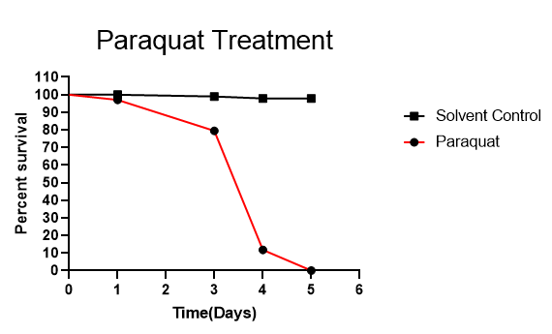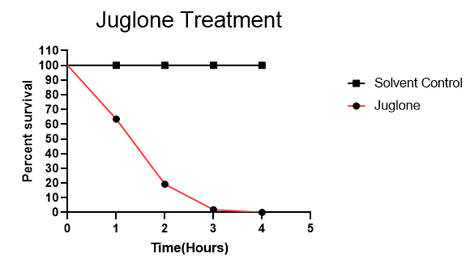
Figure 1 Survival curve of worms after paraquat and juglone treatment
- Duration and Cost of the service
  - The duration time is 3-4 weeks. SUNY will conduct the assay after get well cultured clean strains (at least one week). SUNY will inform the client when SUNY begin and finish the assay.
  - The price for of one/three replicate (s) is $450 and $1200, respectively for every strain/treatment. The price for this order would be for strains/treatment for replicate(s).
  - SUNY will start the experiment after the client confirms the order. If the client needs to modify any order that has already been confirmed and started production, this may incur an additional charge.
- Results SUNY provide
  - The raw data: the list of dates/ hours and corresponding numbers of dead worms for each strain/ treatment under paraquat/ juglone stress.
  - Survival curve of every strain/treatment under the paraquat/ juglone stress.
- How and when to pay
  - T/T (Telegraphic Transfer)
  - If it is client’s first time placing an order with SUNY and the total amount is no more than 3000 USD, no pre-payment is required. Otherwise, SUNY will require a pre-payment that equals to 50% of the total amount of client’s order prior to providing the service.
- Reference
[1] Van Raamsdonk JM, Hekimi S. Deletion of the Mitochondrial Superoxide Dismutase
sod-2 Extends Lifespan in Caenorhabditis elegans. Plos Genetics. 2009 Feb;5(2):e1000361.

