Order Form of Pathogen Infection assay
Date： Jan 18th, 2018
NO.: 20180118
- Information from the client
Table 1 Information from the client
Name: |  | Institute/ university:
PI (If different from above): |  | Department：
Tel: |  | E-mail:
Delivery Address:
Billing Address (If different from above):
Is the client willing to share his/her name, lab, and email address with SUNY’s future clients if they inquire? _______
How did the client learn about SUNY? _________
- Email B) Mail C) Website D) From colleagues or friends
E) Other
(If the client chooses D, please write down the referrer name and institute and SUNY will apply 5% OFF to both the client and the client’s referrer. But please kindly note the 5% OFF is only applicable when the referrer comes from other labs.)
- About this assay
The purpose of this assay is to measure worm’s sensitivity to the P.aeruginosa pathogen infection. For every strain, one/ three replicate(s) will be conducted. For every/ three replicate(s), at least 80/ 240 worms will be tested, and the data of 67/200 worms will be provided.

- Information about the tested strain and tested drug
  - Please complete the strain information including strain name, genotype, phenotype and culture condition in the below Table 2.
  - If the clients want to treat the worms with specific drugs, please complete the Table 3.
  - Please send all strains/drugs to Sunybiotech. If client’s wild type N2 strain is used as control, please also include the wild type N2 strain when sending strains to SUNY.
  - Is the drug sterilized or not? ( for example: yes, no). If not, please provide the sterilization method . If the syringe driven filtration is required, please choose the pore size of the syringe driven filter (0.22µm or 0.45µm).
  - The drug should be added into for C. elegans culturing. (for example: NGM, OP50).
Table 2 Information of the tested strains
Strain name | Genotype | Phenotype | Culture condition
Table 3 Information about the drugs
 | Drug name/ NO. | Concentration of the stock | Storage condition | Solvent | working concentration | working volume
1
2
3
4
- Method/ protocol
Prepare NGM plates
  - Prepare NGM plates supplemented with FUDR and drug with different concentrations. Plates are seeded with 10 times concentrated OP50 after plates are solidified.
  - Prepare NGM plate supplemented with FUDR, drug of different concentration. Plates are seeded with P.aeruginosa pathogen after plates are solidified.
  - Prepare typical NGM plate seeds with OP50.
Prepare synchronized animals
  - Prepare the synchronized eggs by collecting eggs from adults in one hour, culture the eggs in the 20 °C incubator.
  - The drug treatment begins at L4? stage.
  - The P.aeruginosa pathogen treatment begins at X days after drug treatment. Wash the worms with M9 for three times before transfer to the NGM plates with P.aeruginosa pathogen.
  - Put all these plates at the same 20 °C incubator. Transfer worms to fresh plates with FUDR, drug with P.aeruginosa every 96hs to avoid contamination and starve.
Measuring sensitivity to pathogen infection
  - Record the time and the number of worms that are dead/matricide everyday until all worms die.
  - Animals are considered dead when no movement or pharyngeal pumping is observed after gentle touch to the head. Worms that crawl out of plates will not be counted
Representative results
  - The raw data: a list of dates with corresponding numbers of worms dead will be provided.
  - For the survival curve (Figure 1), the day when the synchronized L4s are transferred to the pathogen is considered as day 0. The total number test in every assay is the sum of worms die in every assay.
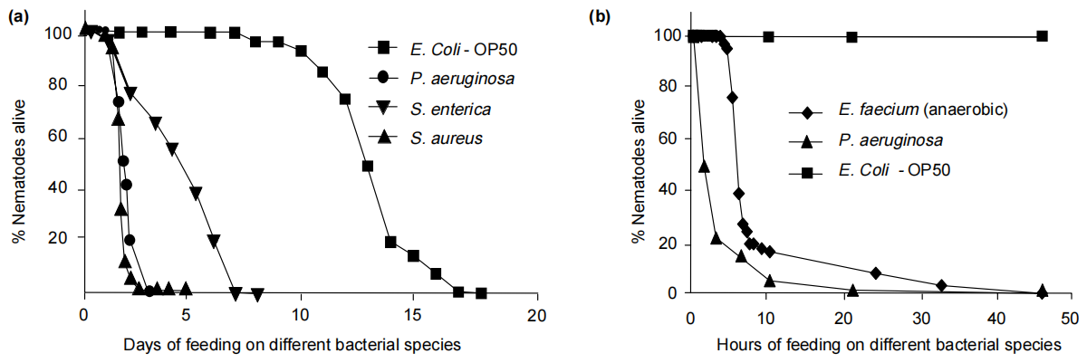
Figure 1 The life spans of worms when feeding on a variety of pathogenic bacteria^{[1]}.
- Duration and Cost of the service
  - The duration time is 3-4 weeks. SUNY will conduct the assay after get well cultured clean strains (at least one week). SUNY will inform the client when SUNY begin and finish the assay.
  - The price of one/ three replicate(s) is $300/ $800 respectively for every strain/treatment. The price would be $ for strains/ treatments with replicate(s).
  - SUNY will start the experiment after the client confirms the order. If the client needs to modify any order that has already been confirmed and started production, this may incur an additional charge.
- Results SUNY provide
  - The raw data: a list of dates with corresponding numbers of worms dead will be provided.
  - The survival curve of every treatment/ strain.
- How and when to pay
  - T/T (Telegraphic Transfer)
  - If it is client’s first time placing an order with SUNY and the total amount is no more than 3000 USD, no pre-payment is required. Otherwise, SUNY will require a pre-payment that equals to 50% of the total amount of client’s order prior to providing the service.
- Reference
[1] Sifri C D , Begun J , Ausubel F M . The worm has turned--microbial virulence modeled in Caenorhabditis elegans.[J]. Trends in Microbiology, 2005, 13(3):119-127.

