Order of the backcross service
Date: Jan 18, 2022
NO.: 202201
- Information from the client
Table 1 Information from the client
Name: |  | Institute/ university:
PI (If different from above): |  | Department:
Tel: |  | E-mail:
Delivery Address:
Billing Address (If different from above):
Is the client willing to share his/her name, lab, and email address with SUNY’s future clients if they inquire? _______
How did the client learn about SunyBiotech? _________
- Email B) Mail C) Website D) From colleagues or friends
E) Other
(If the client chooses D, please write down the referrer name and institute and SUNY will apply 5% OFF to both the client and the client’s referrer. But please kindly note the 5% OFF is only applicable when the referrer comes from other labs.)
- About this service
This service includes heat-shock of the wild type N2 to generate male and four times backcross of the mutant with wild type N2 according to the mating strategy listed below.
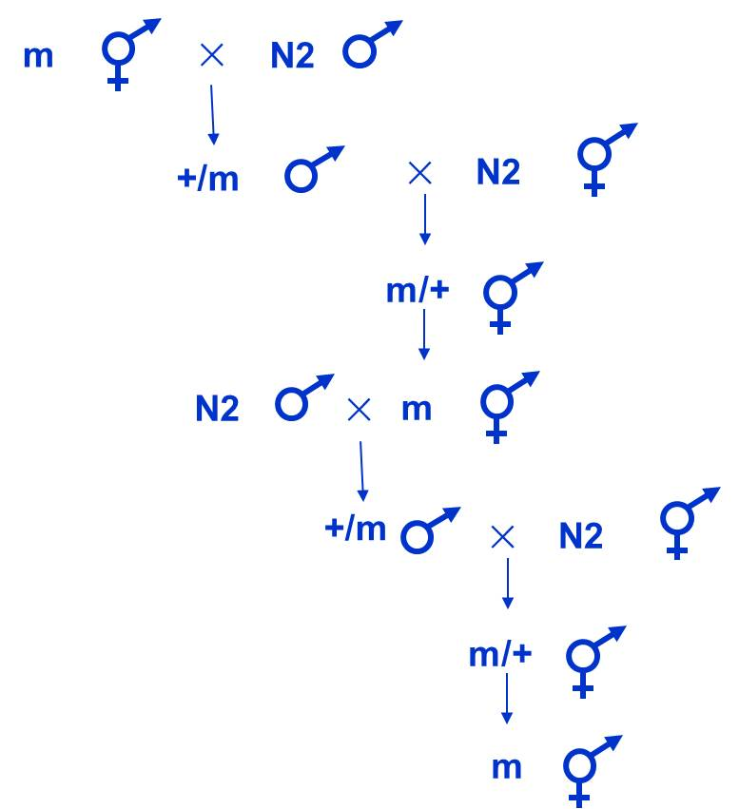
Figure 1 Strategy of four times backcross
- Information about the mutant
  - Strain name and genotype: . Please also send the client’s wild type N2 if it is different from SUNY’s.
  - Phenotype of the strain: .
  - Culture temperature: .
  - Please provide the molecular information of the allele in sequence information part if it is not available on the WormBase.
- Duration and Cost of the service
  - It will take about 8 weeks to finish the backcross.
  - Turnaround time is defined as the time from when an order is confirmed to when it is shipped. It does not include waiting time for any materials that the client needs to supply.
  - Upon receipt of the strain that client sent to SUNY, SUNY will directly use it to start the related experiment. Client is responsible for providing the right strain and ensuring all information is correct. If it is turned to be wrong after the experiment is started, resulting in failure of experiment, there may be additional costs incurred for SUNY's extra work and client should cover the fee of it. During the verification, SUNY will charge $25 for one sequencing reaction (including primer design, primers synthesis, sequencing, sorting of sequence files, etc.).
  - The price for four-time backcross of one mutation is $800. If the strain contains more than one allele and all alleles should be backcrossed, the price of this order would higher than $800.
  - SUNY will start the experiment after the client confirms the order. If the client needs to modify any order that has already been confirmed and started production, this may incur an additional charge.
  - SUNY will charge $40 USD shipping & handling fee for one order, and will apply 3.5% tax to each order.
- Products SUNY provide
  - Gel figures of screening results when isolating heterozygotes and homozygotes after the 2nd backcross and 4th backcross.
  - The final strain after 4 times backcross.
- How and when to pay
  - T/T (Telegraphic Transfer)
  - If it is client’s first time placing an order with SUNY and the total amount is no more than 3000 USD, no pre-payment is required. Otherwise, SUNY will require a pre-payment that equals to 50% of the total amount of client’s order prior to providing the service.
- Sequence information
  - Sequence of the wild type with 500bp flanks:

  - Sequence of the mutation with 500bp flanks

